FORT BLISS
MASSAGE

THERAPY





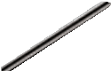


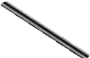



TEXAS LICENSED

bliss.armymwr.com
We are looking for active Texas Licensed Massage Therapists
that understand and believes in the healing benefits of massage therapy and bodywork
MASSAGE
THERAPISTS
to join our Team.
Required Experience:
- Swedish Massage
  - Sports Massage
- Deep Tissue Massage
- Effective Communicator (Verbal & Written)
  - Excellent Customer Service
For more information contact the Fitness Office located at Soto PFC, 20751 Constitution Ave
hone 157570

