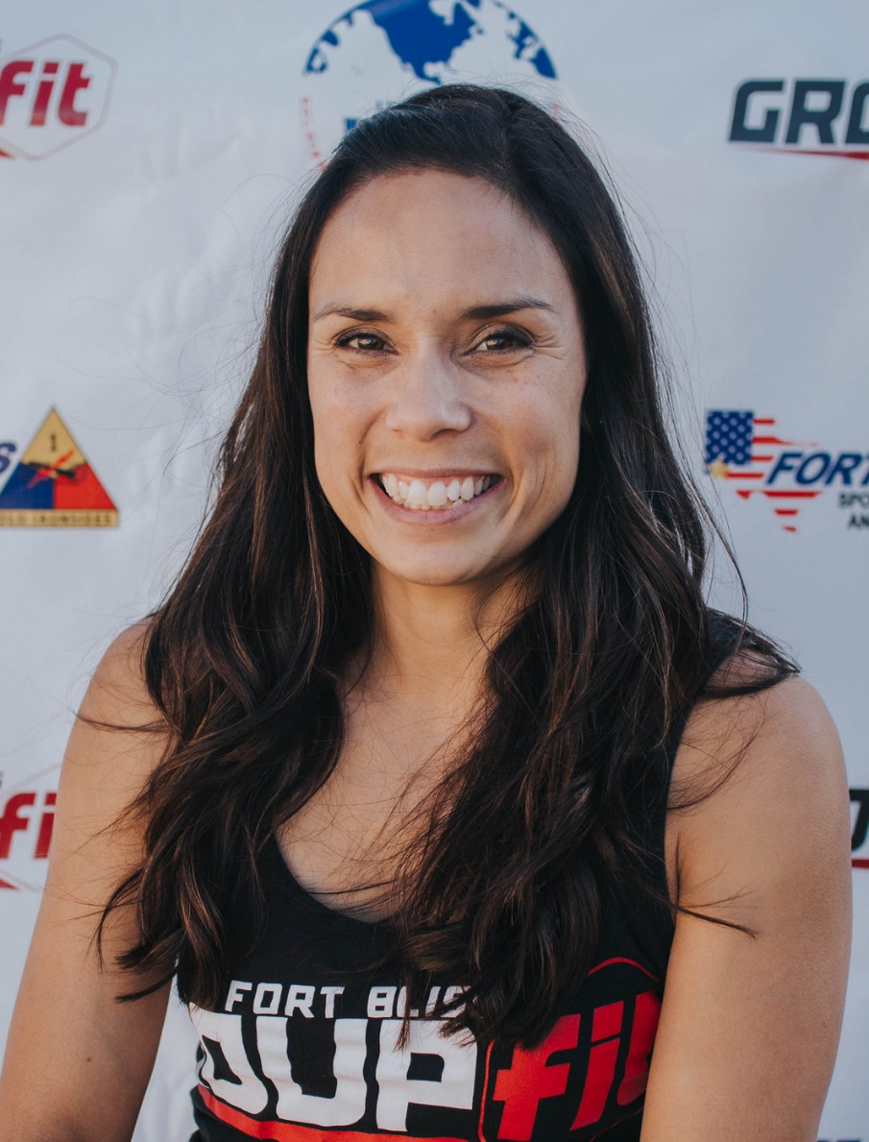
Kirsten

Fitness Philosophy:
To be healthy, you don't have to be an Olympic athlete, you just need to find something you enjoy, something you will stick with, and just keep moving!

Why I am an instructor:
As a FORMER pack and a half a day smoker, I know what it feels like to live life treating your body like garbage... and how AMAZING it feels to treat your body like a temple! I want to be a resource to help others do the same!

Guilty Pleasure:
Pizza and Netflix!!!

Specialties:
Body Pump, Insanity, Pound, Turbo Kick

