Bahiya
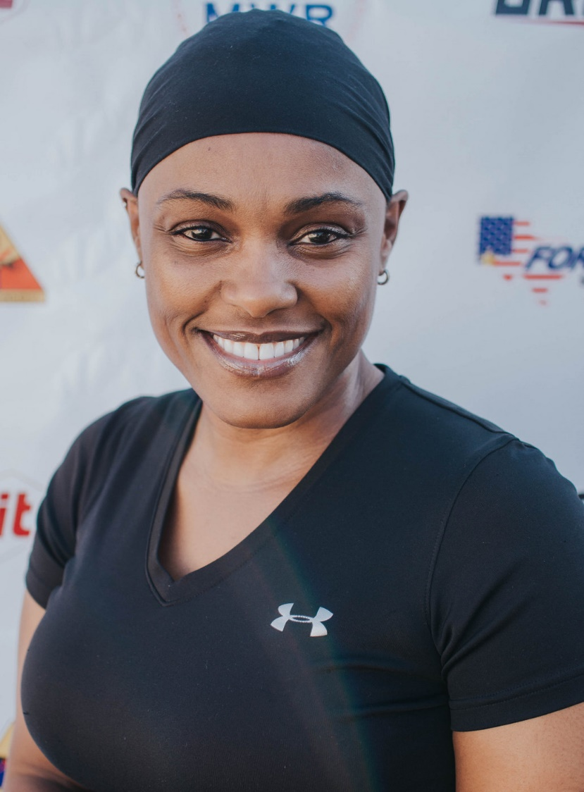

Fitness Philosophy:
To inspire and coach others to be the best version of themselves and live a healthy life!

Why am I an Instructor:
Fitness and nutrition are my passions. As a Fitness Instructor, paying it forward is extremely important and by sharing my love of health and fitness with others, leading them to a healthy lifestyle, is the best way. At the end of the day we all want to best we can be.

My biggest guilty pleasure:
Chocolate

Specialties:
Resistance Training, Indoor Cycling, MiXXed Fit, Pound

