Litsu
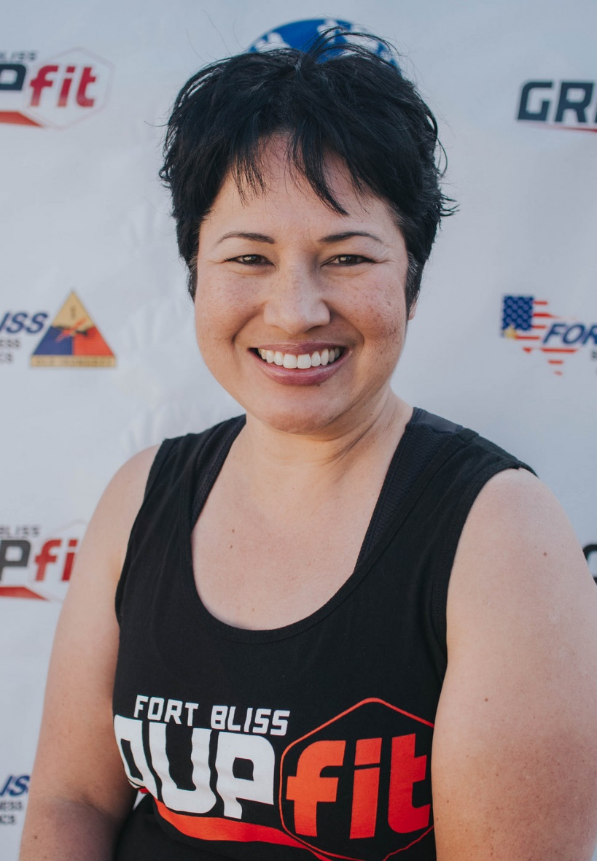
Fitness Philosophy:
Train to live. Enjoy whatever fitness activities you choose because life is too short to be sweating AND miserable.

Why are you an instructor:
It gives me the opportunity to help others take ownership of their well-being with practices that have helped me with my own health challenges.

Biggest guilty pleasure:
Anything and everything chocolate (but not white chocolate!)

Specialties:
Yoga, Aquatics

