Meghan
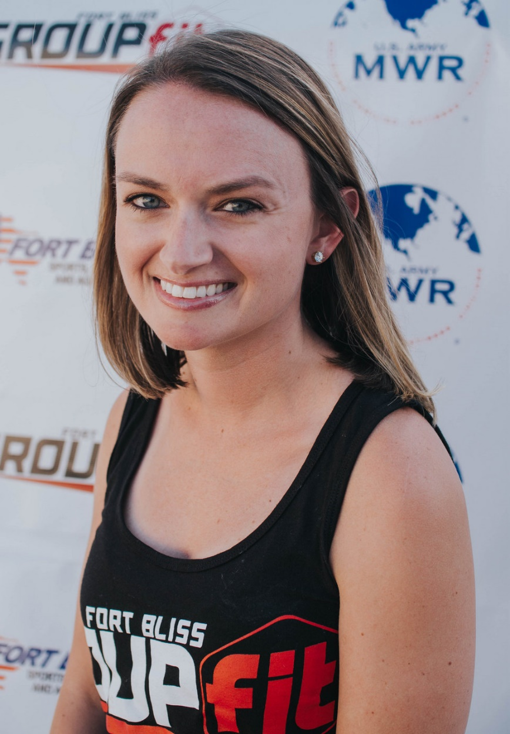

Fitness Philosophy:
Be active for yourself, your family, and your health. Exercise comes in many ways and forms, as long as you find one you love you will keep coming back for more!

Why am an instructor:
I love motivating and encouraging people to be the best they can be!

Biggest guilty pleasure:
French fries!

Specialties:
Body Pump

