Amparo
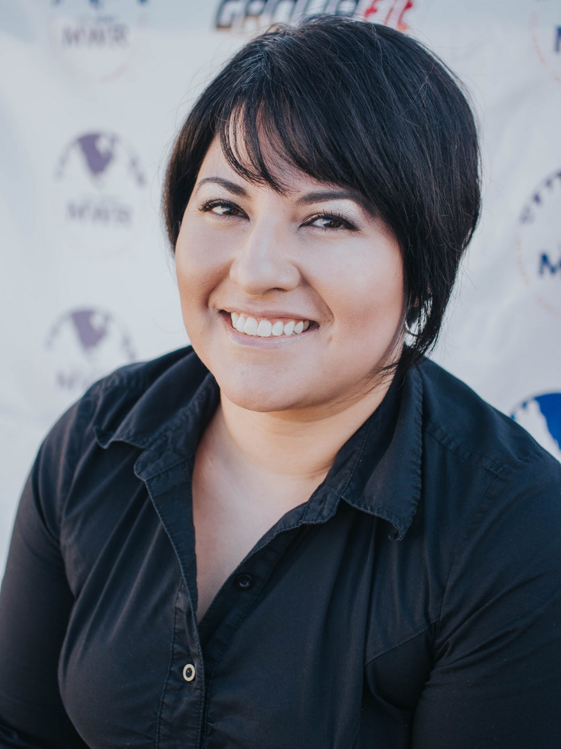
Massage Philosophy:
I truly believe that we have the power within ourselves to choose an overall balanced sense of being.
Why are you a Massage Therapist:
I choose to be a massage therapist because I experienced on a personal level the powerful results of touch therapy.
Biggest Guilty Pleasure:
My guilty pleasure is books. I am obsessed and have hundreds. I am guilty of spending hours browsing on line, in book stores and libraries.

