Richard
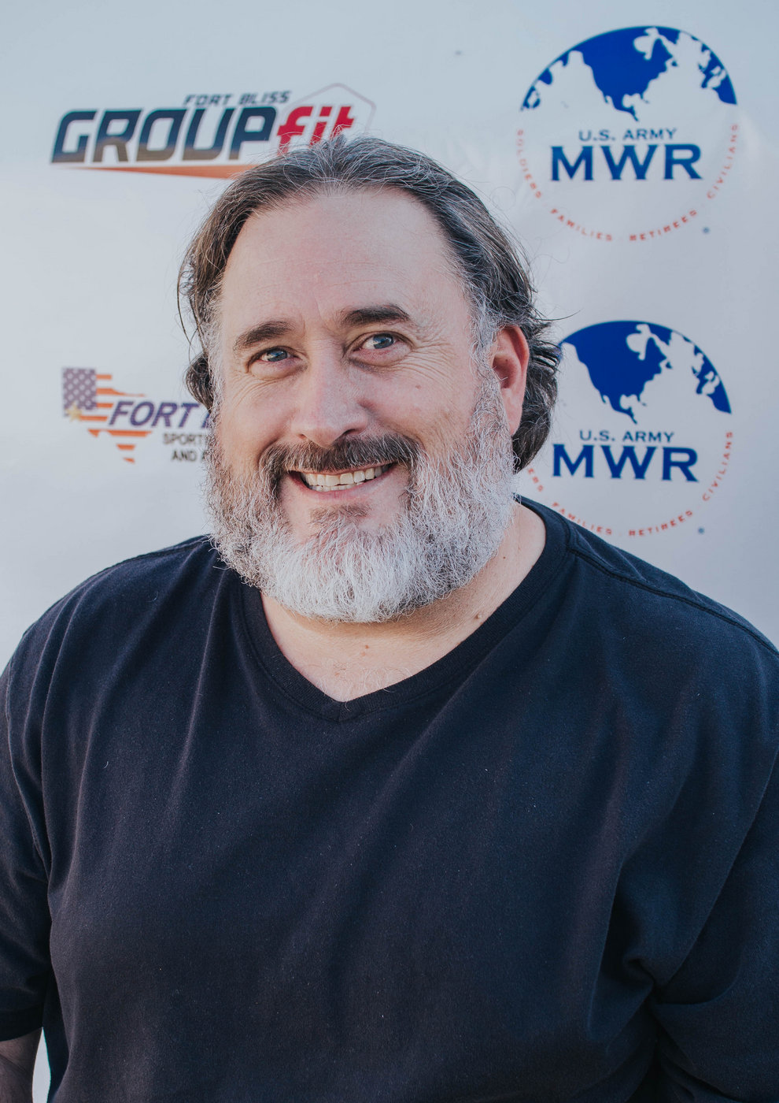
Massage Philosophy:
Touch is a powerful tool.

Why am I a Massage Therapist:
I want to help people and I learned early on that massage was the way I could do that.

Biggest Guilty Pleasure:
Elvira: Mistress of the Dark and Bollywood Movies.

