Edith
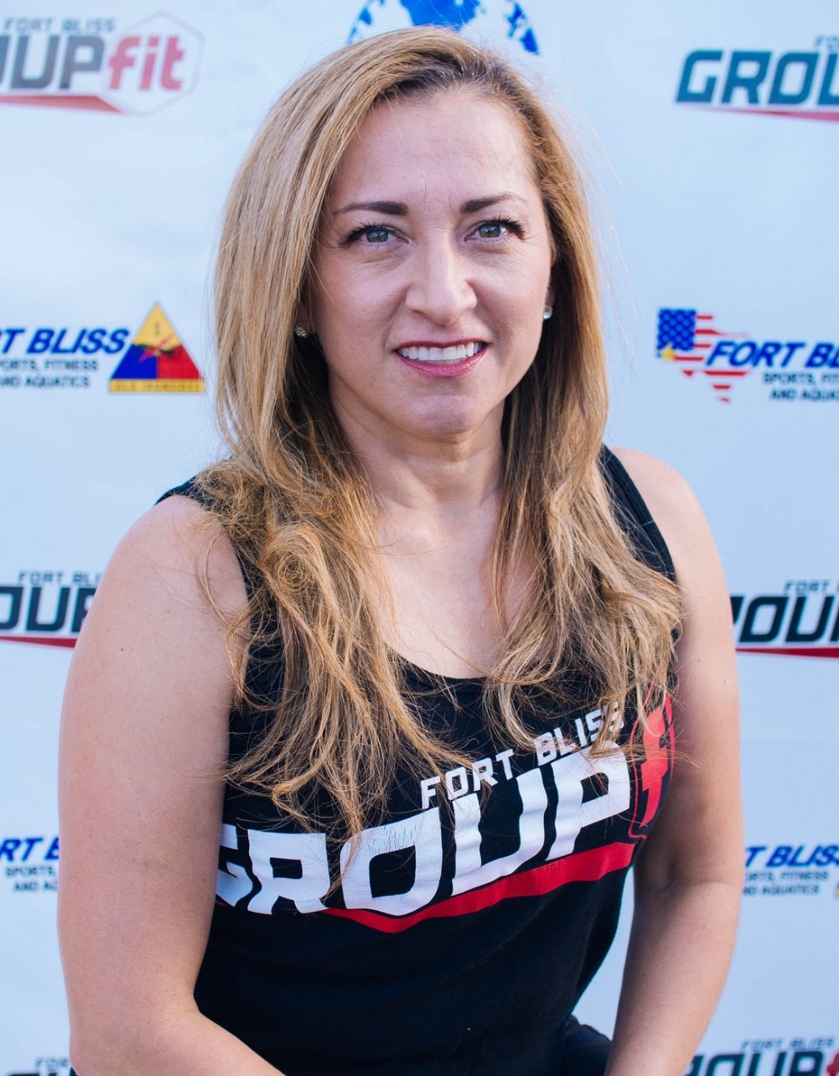
Fitness Philosophy:
Do the best you can then add more to your best!

Why are you an instructor:
Because I love working out and helping people be their best!

Biggest Guilty Pleasure:
Eating a whole family size lays chips with lime and super-hot Valentina!

Specialties:
Indoor Cycling, Pilates,

