Susette
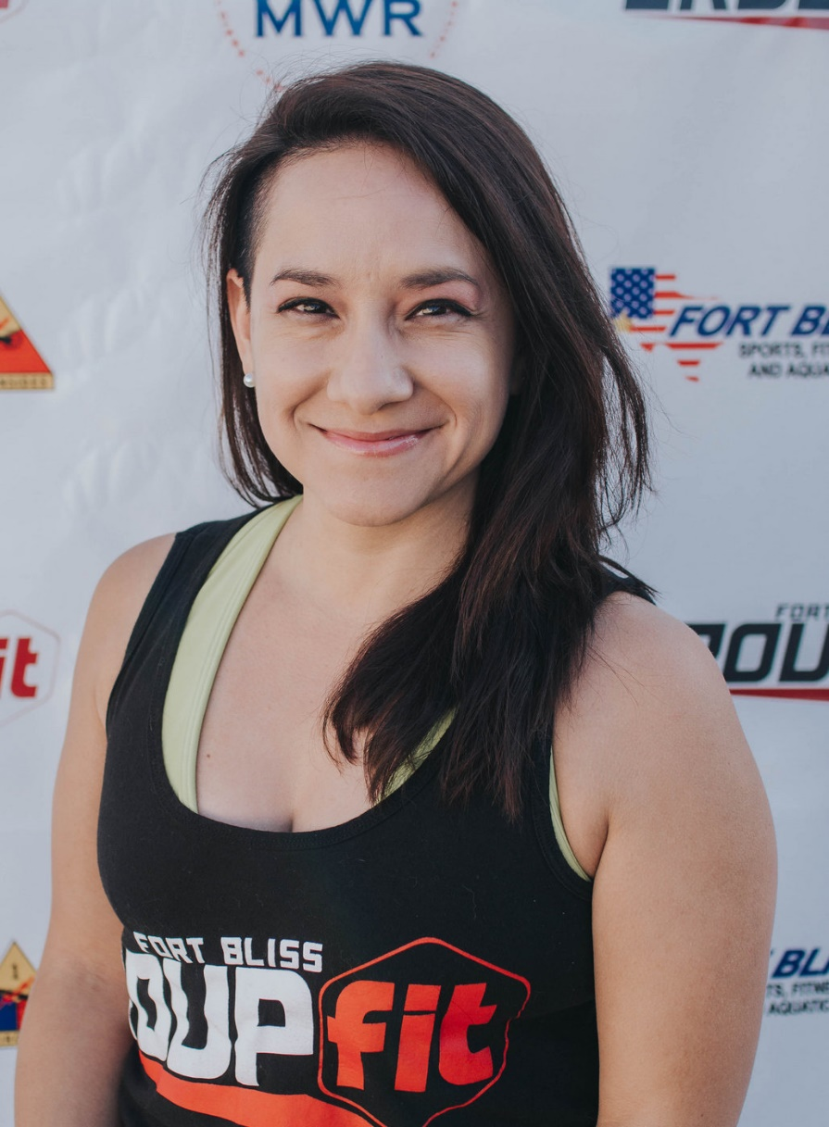
Fitness Philosophy:
Fitness should evolve, challenge, and always be fun. Find what motivates you. No matter how small each goal is. It’s about growing both physically and mentally.

Why are you an instructor:
I never say myself in such a role. Honestly, it was something that was supposed to be temporaly. However, once I saw what went into it and saw the connections and ability to help others I was hooked. A passion that I never knew about me was finally sparked and I was alive!

Biggest Guilty Pleasure:
Definitely craft beer and chocolate!
Specialties:
Pound, Zumba,

