Rosalind
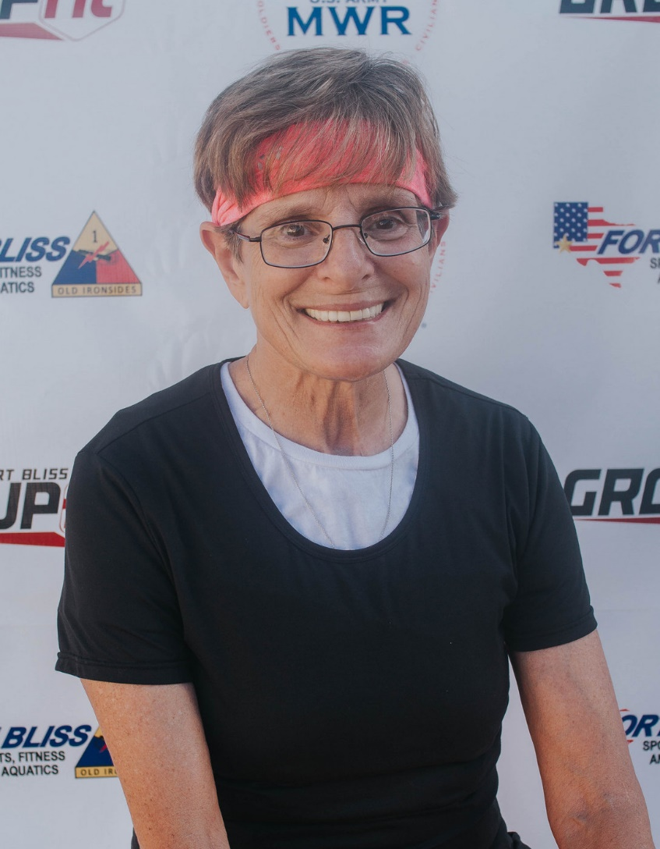
Fitness Philosophy:
Have as much fun while incorporating various types of functional fitness to bring out the best version of you!

Why am I an Instructor:
I have a passion for motivating others and helping them see the fun in FUNctional fitness
Biggest Guilty Pleasure:
Ice cream and the voice!
Specialties:
Indoor Cycling, Total Gym

