Sonia
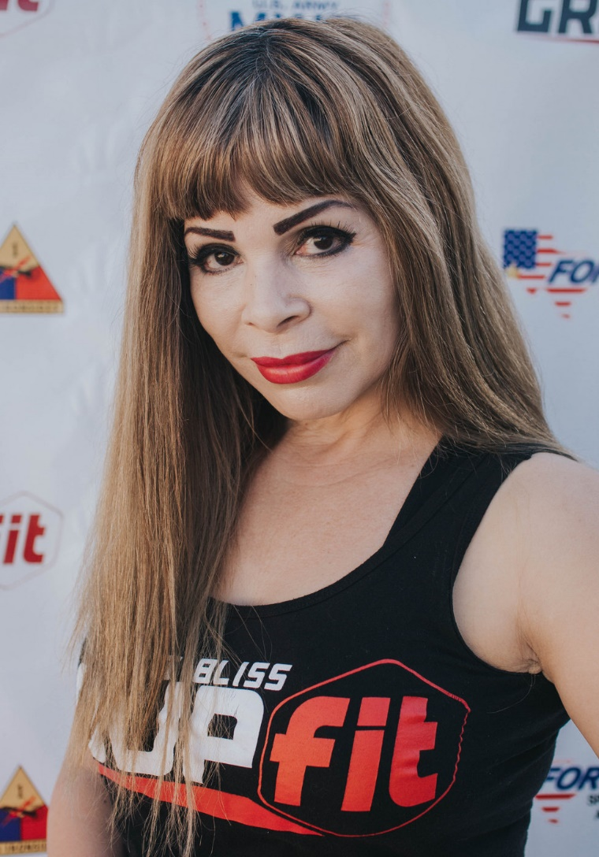
Fitness Philosophy:
Never back down
Never give in
It’s a life change

Why am I an Instructor:
This job is my passion....been an instructor for little more than 10 year...and I just got started!

Biggest Guilty Pleasure:
Sweets and Nachos! Yummy!
Specialties:
Indoor Cycling, Kettlebell Level 1, Pilates, Resistance Training, RIPPED, Total Gym, TRX, Zumba

