Joel
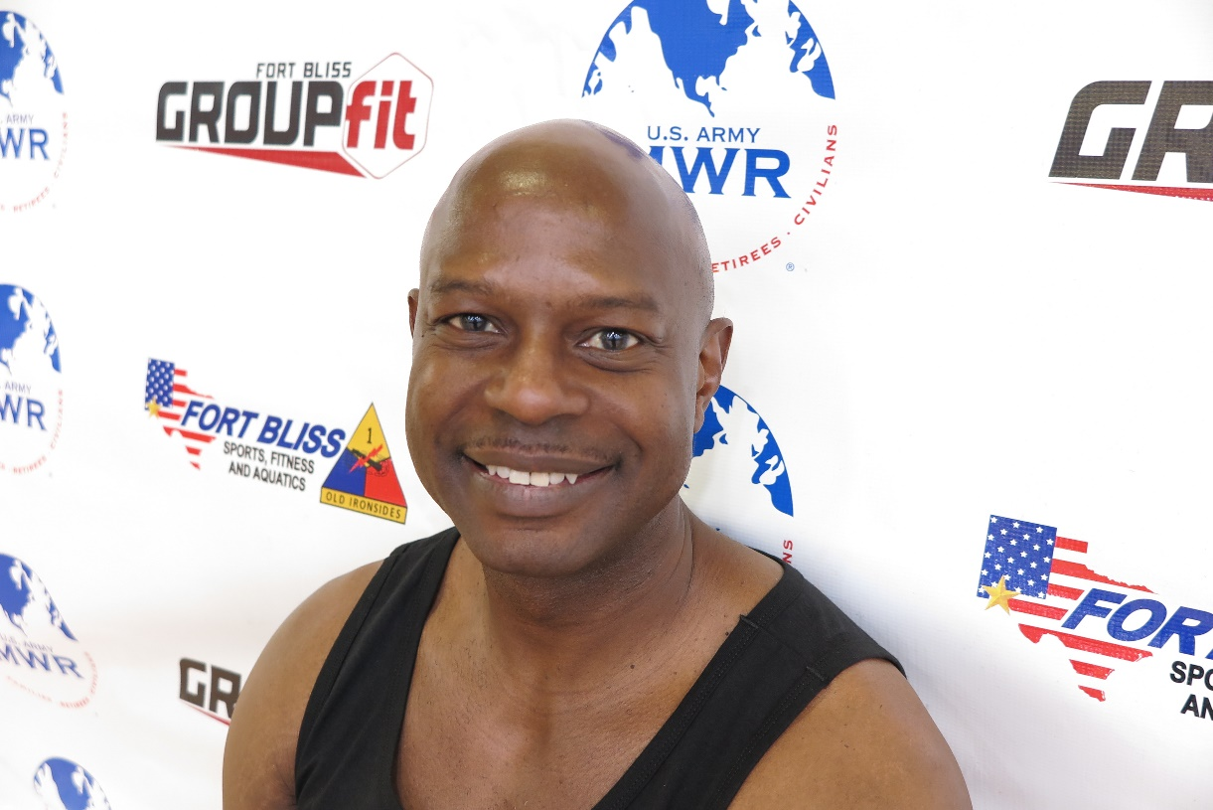
Fitness Philosophy:
Fitness is a life time effort. You should always make time for yourself and your health. Fitness is just not exercise. You also must eat healthy. I know this sounds impossible but you can achieve both when you put your mind to it. Keeping fit gives one a strong mind, body, and soul. An hour a day keeps the doctor away.

Why am I an Instructor:
During my 25 years of military service, I trained my peers and subordinates in physical fitness. I wanted to give back to service-members since retiring. When I heard about becoming a Group Fitness Instructor, I knew it was my chance to pass along knowledge from my military experience. I have also been part of the amateur bodybuilder world in a past life. I have competed in several competitions. This experience has taught me nutrition as well discipline.

Biggest Guilty Pleasure:
I love to eat. I don’t always eat the way a bodybuilder should. I really enjoy ice cream, cookies and cakes. In order to burn it off, it actually makes me workout harder.
Specialties:
Indoor Cycling, Resistance Training

