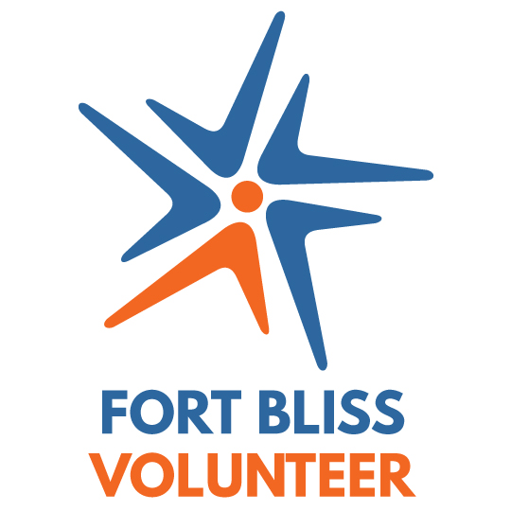
Department of Army
Volunteer Management Information System (VMIS)
How to Guide for Volunteers
The Volunteer Management Information System (VMIS) is the Army’s online volunteer management tool located at www.MyArmyOneSource.com. The system provides a standardized system across the Army for volunteers to document their service history. It also allows for reporting of volunteer activity and statistics at the installation, region, and Department of Army levels. The system will allow you to document your entire volunteer history as you move from Installation to Installation. Per Army Regulation 608-1, all Installations volunteers are required to register in the system and document hours by day each month.
Each organization has an Organization Point of Contact (OPOC) who manages the volunteers and hours within the system. If you don’t know who your OPOC is, contact the Fort Bliss AVCC at (915) 569-5500. All technical and compatibility computer issues should be addressed through the Chat Online link with the Site Technical Support located at the top of the web page located at www.MyArmyOneSource.com.

How do I register in VMIS???
Follow the easy steps below to register

If you are not registered on the website, START HERE.
1. Go to www.MyArmyOneSource.com.
2. Click on the Register link in the upper right corner.
3. Click on Join Now and complete the registration information.
4. Click Continue.
5. Verify information and click Register at the bottom right hand corner.
6. Screen will show “Registration is Being Processed” and “Thank You for Registering”. You have.
7. Click Continue (returns to your homepage).
8. Click on the Volunteer Tools tab in the upper right corner.
9. Click on Texas (TX) on the map.
10. Click on Fort Bliss Community
11. Select an Organization Group and then the Organization, then click the Search button; OR scroll through the volunteer opportunities listed at the bottom of the page.
12. Click on the Position title (position description will open – review to ensure this is the position you are looking for).
13. Click on Apply in the right hand corner, complete any required fields, then click on Submit in the bottom right corner.
If you are registered on the website, START HERE.
1. Go to www.MyArmyOneSource.com and log in.
2. Click on the Volunteer Tools tab in the upper right corner.
3. Already a Volunteer? Click on Click Here tab.
4. Click on Fort Bliss community.
5. Select an organization Group and then the Organization, then click the search button; OR scroll through the volunteer opportunities listed at the bottom of the page.
6. Click on the Position title (position description will open – review to ensure this is the position you are looking for).
7. Click on Apply in the right hand corner.
8. Scroll to the bottom and click on Submit.
9. The scree will return to home page.

An email will go to your Organization Point of Contact (OPOC). The OPOC will then approve or reject your application. Once approved, you may then begin to log your hours. Hours must be input by the 5th of the month of the previous month – see instructions on the back page.
*** Note for MAC users, please download FireFox as your Internet Web Browser

LOG YOUR HOURS…
1. Go to www.MyArmyOneSource.com and log in.
2. Click on Volunteer Tools tab in the upper right hand corner.
3. Click on Volunteer Activity.
4. Click on the Hours button (highlighted in blue) next to your position.
5. To enter for the current month, select Day, & Add for Open Dates.
6. When you are finished entering hours, be sure to scroll to the bottom and click SAVE!
7. Historical hours may be added to ensure your volunteer service record is accurate. Please see your OPOC for assistance as they can assist with your logging back hours in the VMIS system with proper hours verification provided.
UPDATE YOUR PROFILE (EMAIL, ADDRESS, PHONE #, ETC.)…
1. Go to www.MyArmyOneSource.com and log in.
2. Click on Update Profile Box in upper right corner.
3. Click on Edit Profile.
4. Click on SAVE when done.

HOURS MUST BE ENTERED INTO THE SYSTEM BY THE 5TH OF THE MONTH FOR THE PREVIOUS MONTH TO ENSURE CERTIFICATION.

